

**CMPE-277: Smartphone application Development**

**Assignment 3 – BROADCAST RECEIVER**

**Submitted to:** Prof. Chandrasekar Vuppalapati

**Submitted by:** Anuradha Rajashekar

(SJSU ID: 012409956)

1. 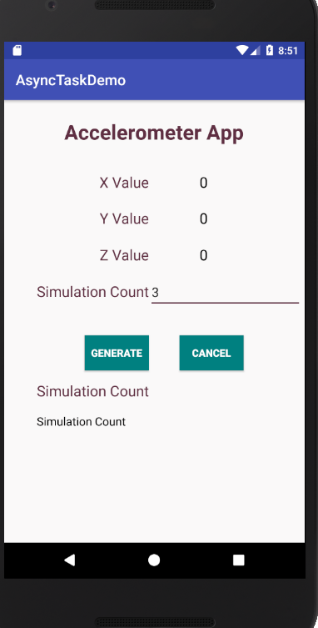The below screenshot is the UI of Async task App. It takes simulation count as the input and on click of generate random number is generated and simulation count keeps a track on all the numbers generated within async task.
2. 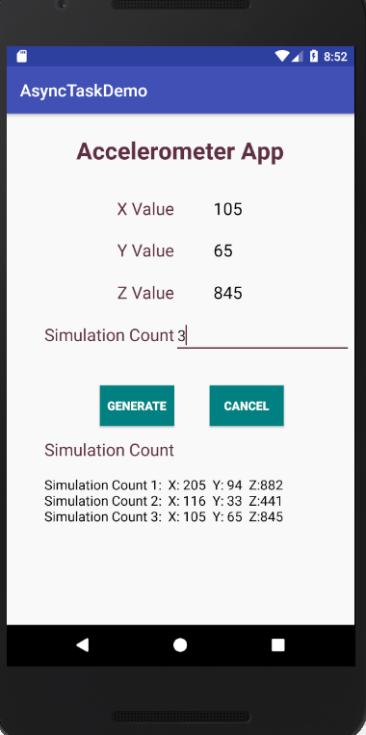Below screenshot shows the simulation count generated .